Getting Started with AI model building
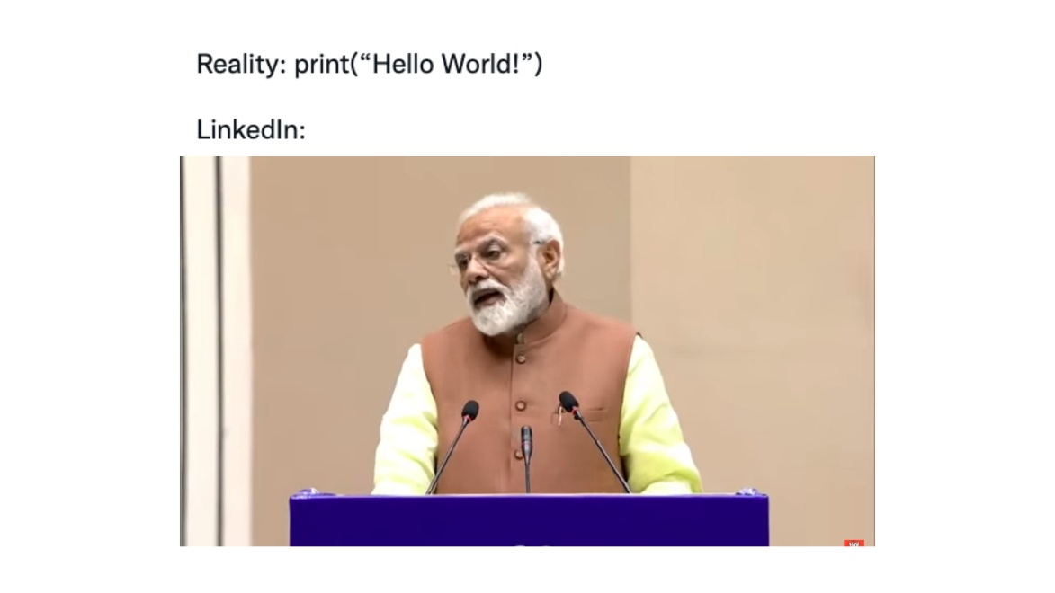

Hello Tanveer Singh Bhandari

Here are some materials that may or may not help you

Fast AI Deep Learning course:
Practical Deep Learning for Coders - Practical Deep Learning
If you finish this course I will think you’re a pro cause I did course and I call myself a pro.
I assume you have some python knowledge if not watch some youtube videos before.
Everything is free unlike AWS
Part 1 should be enough but do part 2 if you want something harder…

Part 1: Practical Deep Learning (2-3 months, 60-100 hours)
What you build:
- Image classifiers and deploy them as web apps
- NLP models (sentiment analysis, text generation)
- Recommendation systems
- Tabular data predictions
- Custom models for your own projects
Time: 1-2 hours/day for 2-3 months Focus: Getting working models quickly, practical applications

Part 2: Deep Learning from Foundations (3-4 months, 100-150 hours)
What you build:
- PyTorch from scratch
- Your own neural network framework
- Transformers and diffusion models
- Research paper implementations
Time: 1-2 hours/day for 3-4 months Focus: Understanding internals, building everything from zero

Tech Stack:
Core Deep Learning
- fastai - High-level library (the main framework)
- PyTorch - Underlying framework (comes with fastai)
- torchvision - Computer vision utilities
- CUDA/cuDNN - GPU acceleration (handled automatically)
Data Processing
- pandas - Tabular data manipulation
- numpy - Numerical operations
- scikit-learn - Classical ML utilities
- PIL/Pillow - Image processing
- OpenCV (occasionally) - Advanced image operations
Visualisation
- matplotlib - Basic plotting
- seaborn - Statistical visualisations
- TensorBoard (optional) - Training metrics
NLP Libraries
- Hugging Face Transformers - Pre-trained models
- tokenizers - Text tokenisation
- spaCy (occasionally) - Text preprocessing
- sentencepiece - Subword tokenisation
Development Environment
- Jupyter/JupyterLab - Interactive notebooks
- Google Colab or Kaggle Kernels - Cloud notebooks
- Git/GitHub - Version control
- nbdev (Part 2) - Notebook-driven development
Deployment
- Gradio - Quick web interfaces
- Streamlit (alternative) - Web apps
- Hugging Face Spaces - Model hosting
- FastAPI/Flask (optional) - APIs
- Docker (optional) - Containerisation
- ONNX (mentioned) - Model export
Data Sources/Tools
- wget/curl - Download datasets
- Kaggle API - Dataset access
- DuckDuckGo/Bing API - Image collection
- ImageNet - Pre-trained weights
Part 2 Specific
- Pure Python - Building from scratch
- NumPy (heavy use) - Matrix operations
- Numba - JIT compilation
- CuPy (optional) - GPU arrays
- einops - Tensor operations
- wandb (Weights & Biases) - Experiment tracking

Build your own thing (I recommend):
You could also just build your own thing using a similar tech stack:
Can find loads of data sets from Kaggle

If you want to build a regression model: i.e for price prediction
- pandas for data manipulation
- scikit-learn for model training (LinearRegression, RandomForestRegressor)
- matplotlib/seaborn for visualisations
- Jupyter notebooks for experimentation i.e run the code easily
Key concepts: Feature engineering, train/test splits, cross-validation, evaluation metrics (MSE, R²)

If you want to build a Churn prediction model:
- pandas, numpy for data processing
- scikit-learn (LogisticRegression, XGBoost)
- imbalanced-learn for handling unbalanced data
- SHAP for model interpretability
Key concepts: Binary classification, handling imbalanced datasets, feature importance

For sentiment analysis:
- NLTK or spaCy for text preprocessing
- Hugging Face Transformers for pre-trained models
- PyTorch or TensorFlow for custom model
Key concepts: Text preprocessing, tokenisation, embeddings, transfer learning

For image classification:
- TensorFlow/Keras or PyTorch
- OpenCV or PIL for image preprocessing
- Albumentations for data augmentation
- Pre-trained models: ResNet, VGG16 from torchvision
Key concepts: Convolutional layers, data augmentation, transfer learning

To build your own chatbot:
- OpenAI API or Hugging Face models
- LangChain for chaining prompts
- ChromaDB or Pinecone for vector storage
- Gradio or Streamlit for UI
- FastAPI for serving
Key concepts: Prompt engineering, embeddings, retrieval-augmented generation

Car related project ideas:
Number plate recognition:
- EasyOCR - Reads the plate text
- OpenCV - Handles images/video
- Streamlit - Creates web interface

Key words and concepts
Machine Learning Fundamentals
Feature engineering: Creating or transforming raw data into useful inputs for your model. Like turning "date of birth" into "age" or combining "total sales" ÷ "number of customers" to create "average sale value". It's crafting the right ingredients before cooking.
Train/test splits: Dividing your data so you train the model on one portion (usually 80%) and test it on unseen data (20%). Like revising with practice papers but keeping the final exam hidden until you're ready to test yourself.
Cross-validation: Instead of one split, you divide data into chunks (say 5), train on 4, test on 1, then rotate which chunk is the test set. Gives you 5 different accuracy scores to average. More reliable than a single split.
Evaluation metrics (MSE, R²)
- MSE (Mean Squared Error): Average of squared differences between predictions and actual values. Penalises big mistakes heavily.
- R²: Tells you what percentage of variation your model explains. R²=0.9 means your model explains 90% of the patterns in the data.
Classification Concepts
Binary classification: Predicting yes/no outcomes - is this email spam? Will this customer leave? Is this transaction fraudulent? Only two possible answers.
Handling imbalanced datasets: When you have way more of one class (99% legitimate transactions, 1% fraud). Need special techniques because model could just predict "legitimate" always and be 99% accurate but useless.
Feature importance: Which inputs matter most for predictions. In house prices, "location" might be 40% important, "size" 30%, whilst "paint colour" is 0.1%. Helps you understand what drives your model's decisions.
NLP/Text Concepts
Text preprocessing: Cleaning text for models - removing punctuation, converting to lowercase, fixing typos, removing stop words ("the", "a"). Like cleaning vegetables before cooking.
Tokenisation: Breaking text into pieces the model can understand. Could be words: ["I", "love", "coding"] or subwords: ["I", "lo", "ve", "cod", "ing"]. It's how models "read" text.
Embeddings: Converting words/sentences into numbers (vectors) that capture meaning. "King" and "Queen" would have similar number patterns, as would "happy" and "joyful". It's like GPS coordinates for words.
Deep Learning Concepts
Convolutional layers: Layers that scan across images with small filters looking for patterns - edges, shapes, textures. Like having many small detective windows sliding across a picture, each looking for specific clues.
Data augmentation: Creating variations of your training data - rotating images, changing brightness, flipping horizontally. Helps model learn that a cat is still a cat even if photo is tilted or darker.
Transfer learning: Using a model trained on millions of images (like ImageNet) and adapting it for your specific task with just hundreds of images. Like hiring an experienced chef and teaching them your restaurant's specific recipes.
Modern AI Concepts
Prompt engineering: Crafting the right instructions/questions to get best results from AI models. "Write a story" vs "Write a mystery story set in Victorian London with a detective who solves crimes using chemistry" - the second prompt gets better results.
Retrieval-augmented generation (RAG): Instead of AI using only its training, it first searches a database for relevant information, then generates answers using that context. Like letting ChatGPT Google things before responding. How your bp GenAI implementations probably work.

[I did not write this section; copilot did cause I’m lazy]
In the same way you can learn the key concepts and use cluade or chatgpt to help you build something lol.

